UNIVERSITY OF MUMBAI

### A PROJECT REPORT ON

**Application Development**

SUBMITTED BY

Mr.Gaurav Sonu Umbarkar (Roll No. 58)

**Master of Computer Applications**

2017-2020

### UNDER THE GUIDANCE OF

Name of External Mentor

Mr. Tushar Ghanolkar

CRISIL Ltd.

Team Lead

Name of Internal Mentor

Prof. Sudarshan Shirsat

K.J. Somaiya Institute of Management Studies and Research

SUBMITTED TO

K.J. SOMAIYA INSTITUTE OF MANAGEMENT VIDYANAGAR, VIDYAVIHAR (E), MUMBAI - 400077

**Declaration**

In the documentation of the project based on Application Development, all the examples taken to explain the concepts are demo and relates none to the actual company examples. Care has been taken to abide by all company compliance norms and hence none of the internal, private or confidential information has been published in this project documentation. Technical terms known to the public are only used and hence none of the company specific terms are published in this project documentation. The code snippet used is the sample code and none of the actual code is published in this documentation.

Gaurav Sonu Umbarkar

K.J. Somaiya Institute of Management Studies and Research, Vidyavihar

MCA (17-20)

Semester VI

[gaurav.umbarkar@somaiya.edu](mailto:gaurav.umbarkar@somaiya.edu)

**Page 3 : Certificate from the Institute**

Certificate of completion of project report from the Institute (to be scanned and included in the project report after obtaining all necessary approvals and signature)

**Page 4 : Certificate from the Organization**

Certificate of completion of project on company’s letterhead (to be scanned and included in the project report after obtaining all necessary approvals and signature)

**Page 5 : Acknowledgement** (Should be approved by Internal Project Mentor)

I am grateful to Prof. **Sudarshan Shirsat**, My Project Guide, and Internal Mentor, who was a constant source of help and played an important role in the successful execution of the project.

I would like to thank CRISIL Ltd. for providing me a platform to learn and work.

Would like to thank my associate director Mr. **Tushar Ganorkar** for their support, help and guidance throughout the project and for continuous help providing me with the right kind of work experience.

I would like to extend my heart-felt gratitude to my senior Mr. **Satyendra Kumar** for his continuous support, valuable inputs, comments and reviews for executing the project at hand.

**Index**

|  |  |  |
| --- | --- | --- |
| **Sr.No** | **Title** | **Page No.** |
| 1. | Company Profile | 7 |
| 2 | Abstract | 11 |
| 3 | Introduction | 12 |
| 4 | Domain knowledge | 13 |
| 5 | Training | 16 |
| 6 | Hardware and Software Requirement | 22 |
| 7 | Feasibility Study | 23 |
| 8 | Implementation | 24 |
| 9 | My Role as Software Developer | 27 |
| 10 | Development Tools | 28 |
| 11 | Testing | 31 |
| 12 | Conclusion | 37 |
| 13 | References | 38 |

**Company Profile**

**CRISIL** is an Indian analytical company providing ratings, research, and risk and policy advisory services and is a subsidiary of American company S&P Global. We are India’s foremost provider of ratings, data, high-end research, analytics, and solutions to the world's largest banks and leading corporations. A strong track record of growth, culture of innovation and global footprint sets us apart. We have delivered independent opinions, actionable insights, and efficient solutions to over 100,000 customers. Our businesses operate from India, the United States (US), the United Kingdom (UK), Argentina, Poland, China, Hong Kong, Singapore, and the United Arab Emirates (UAE). It is a leading, agile and innovative global analytics company driven by its mission of making markets function better.

CRISIL, was the first credit rating agency in India, introduced in 1988 by the ICICI and UTI jointly with share capital coming from SBI, LIC and United India Insurance Company. In April 2005, US based credit rating agency S&P acquired the majority shares (51 percent) of company.

Our clients range from micro, small and medium companies to large corporates, investors, and top global financial institutions. We work with commercial and investment banks, insurance companies, private equity players and asset management companies globally. We also work with governments and policy makers in the infrastructure space in India and in other emerging markets. We help clients manage and mitigate risks, take pricing and valuation decisions, reduce time to market, generate more revenue and enhance returns.

By helping shape public policy on infrastructure in emerging markets, CRISIL helps catalyse economic growth and development in these geographies.

**Ratings :-**

CRISIL pioneered credit rating in India in 1987, and emerged a leader with our independent, analytical rigour and innovation. As a full-service rating agency, CRISIL rate the entire gamut of debt instruments, and provide a globally unique and affordable rating service for SMEs. CRISIL not only set business standards but also instituted several innovations with our best practices.

CRISIL serve lenders, investors, issuers, market intermediaries and regulators by covering manufacturing companies, banks, NBFCs, PSUs, financial institutions, state governments, urban local bodies, and mutual funds.

Issuers and borrowers leverage our ratings for enhancing their access to funding, widening range of funding alternatives, and optimising cost of funds. Investors and lenders use our ratings to supplement their internal evaluation process and benchmark credit quality across investment options. Our ratings act as benchmarks for pricing and trading of debt instruments for markets at large.

CRISIL pioneered the first corporate sector rating in 1988. Today, one out of every two companies in India is rated by CRISIL. We have an unmatched coverage of about 70 sectors belonging to 22 industry groups.

Our probability of default approach on a standardized 20-point rating scale is approved by the Securities and Exchange Board of India and the Reserve Bank of India.

CRISIL follows a three pronged approach to arrive at the standalone credit rating of a given firm, comprising evaluation of:

* Business risk – factors in industry risk, market position, and operating efficiency of the entity.
* Management risk – considers competence, integrity and risk appetite of the firm’s management.
* Financial risk – assesses accounting quality, present and future financial position, cash flows, and financial flexibility of the firm. Project based risks are also factored in at this stage.

**SME Solutions :-**

CRISIL has graded and assessed 144,000+ micro, small and medium enterprises (MSMEs) across sectors, making us India’s foremost provider of such solutions. These gradings and assessments have boosted the MSME sector by enabling fast and accurate decision-making by financial institutions and improving access to affordable finance. We also play a key role in SME supply chains by evaluating and benchmarking the performance of dealers, vendors, customers, franchisees and partners of large corporates. Our evaluations offer 360-degree insights into the financials, management capabilities and business risks, which helps MSMEs improve their operational and financial performance.

CRISIL is the premier provider of assessment for micro, small and medium enterprises (MSMEs). These include customised evaluations and performance benchmarking of counterparties that constitute the supply-chain network of large corporates, and business portfolio of financial institutions.

CRISIL SME grading facilitates a 360-degree insight into the financials, management capabilities and business risks of SMEs. This enables corporates to optimise their operations and engagements with SME counterparties and financial institutions to establish the SME’s credentials.

CRISIL’s SME offerings provide an independent verification, evaluation and assessment to establish credibility and enhance confidence of potential customers, suppliers and lenders. The offering provides access to funding as our grading matters to lenders and can help obtain faster credit. CRISIL grading is an indicator of overall credit worthiness of the entity, arrived at by analysing operating performance and financial strength.

**Global Analytical Centre :-**

CRISIL’s Global Analytical Centre (GAC), provides analytical, research and data services to S&P Global (earlier known as McGraw Hill Financial) globally. The GAC support encompasses research and analysis, complex data analytics and modelling assignments, risk and regulatory services, and improving workflow efficiency. GAC acts like a centralised research and analytics hub for SPGI teams spread across US, EMEA and APAC regions.

**GAC Services Include:**

* Credit analytics
* Industry, Company, and Country research
* Data management and enrichment (including specialised, adjusted economic data)
* Modelling and forecasting (including quantitative research and analytics)
* Sales and Marketing support
* Risk Management and Compliance Analytics

GAC support goes beyond Ratings and pans across critical and emerging focus areas for S&P Global. As a global research unit, GAC allows quick and seamlessly implementation of global initiatives, and assists S&P Global in its mission to deliver essential intelligence.

* GAC enables standardisation and consistency of analysis and workflows through its centralised operations.
* GAC’s round-the-clock support on critical time-sensitive assignments enables SPGI increase coverage and improve time-to-market of analysis, insights and opinions.
* Create operating efficiencies by leveraging GAC’s culture of continuous improvement through lean management tools and process re-engineering.

**Abstract**

This project report is about the work and processes that was done during the five months of Internship starting from 15th of January to 12th of June 2020. This report describes the training phase as well as the nature of work done on various projects in the organization. I also mention what kind of corporate culture CRISIL has and how it help me to develop my corporate skills.

During the period of internship I worked on many different projects which further helps me to increase my domain knowledge as well as my technical skills. This report will give details about the work done on the period of internship, the technology and various tools that used as well as skills that acquired during that period. The report gives detail about the training phase of the tools that were learnt. Training phase mostly depended mostly on the Knowledge Transfer As none of the information of the working of the tools is present on the internet.

**Introduction**

The internship basically revolves around learning the entire process of SDLC (Software Development Life Cycle). As discuss earlier CRISIL pioneered credit rating in India in 1987, and emerged a leader with our independent, analytical rigour and innovation. As a full-service rating agency, CRISIL developed various tools and platforms to perform analysis and rating operation quickly as well as effectively. CRISIL not only set business standards but also instituted several innovations with various best practices.

Software Development Life Cycle (SDLC) is a process used by the software industry to design, develop and test high quality software. The SDLC aims to produce a high-quality software that meets or exceeds customer expectations, reaches completion within times and cost estimates.

SDLC is a process followed for a software project, within a software organization. It consists of a detailed plan describing how to develop, maintain, replace and alter or enhance specific software. The life cycle defines a methodology for improving the quality of software and the overall development process.

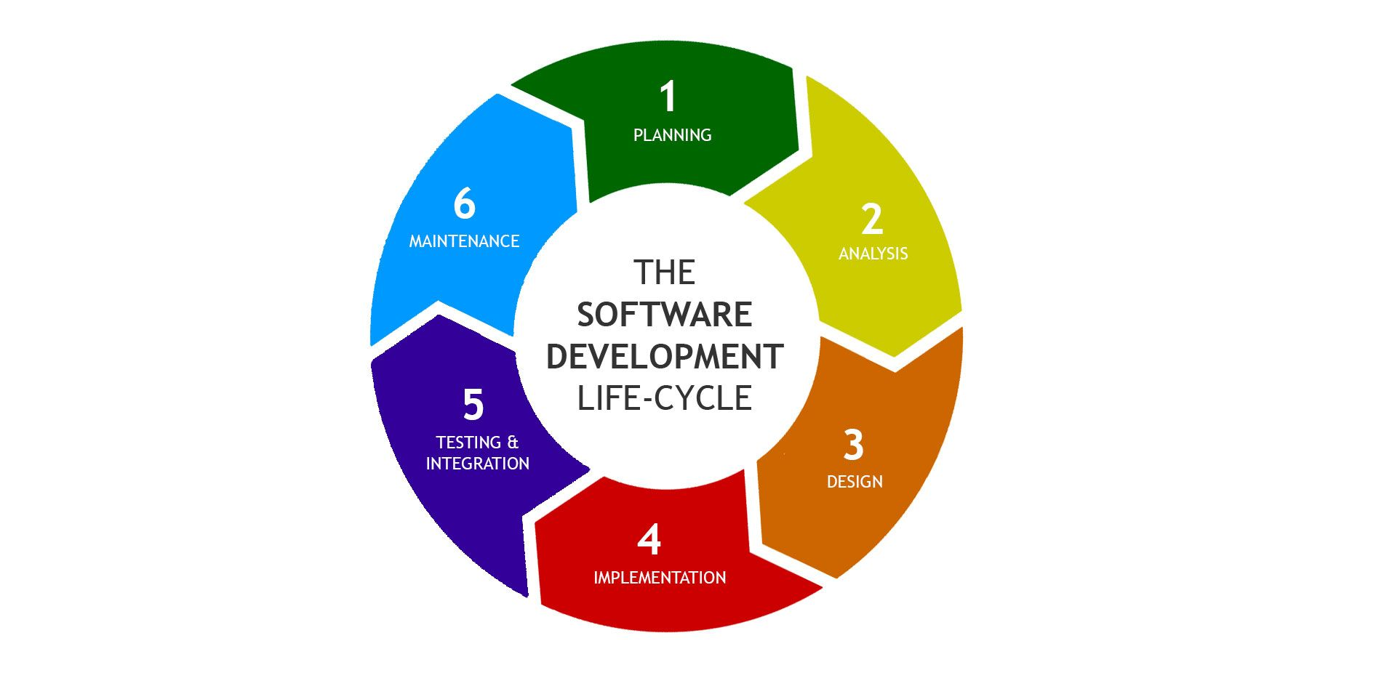

**Domain Knowledge**

1. **Rating: -** CRISIL pioneered credit rating in India in 1987, and emerged a leader with our independent, analytical rigour and innovation. CRISIL serve lenders, investors, issuers, market intermediaries and regulators by covering manufacturing companies, banks, Non-Banking Financial Companies (NBFCs), public sector undertakings (PSUs), financial institutions, state governments, urban local bodies, and mutual funds. These ratings act as benchmarks for pricing and trading of debt instruments for markets at large.

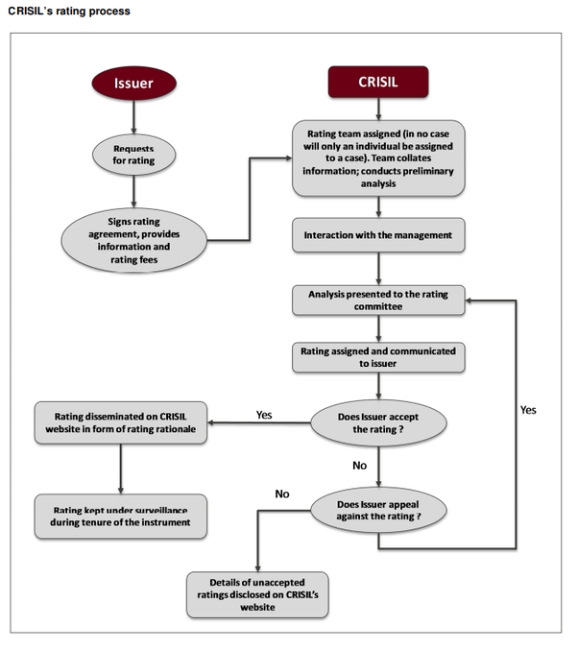

1. **Business Intelligence & Risk Management: -** CRISIL’s Business Intelligence & Risk Management Solutions help banks and financial institutions in their data and analytics needs. This includes all key functional areas such as Risk Management, Sales & Marketing, Financial Control & Reporting, Regulatory Compliance and Governance.

CRISIL worked with over 100 banks and financial institutions for innovative solutions that aid decision making across Corporate & Investment Banking, Commercial & Retail Banking, Cards, Asset Management and Insurance domains.

1. **Research: -** CRISIL is India's largest independent integrated research house, providing insights, opinion and analysis on the Indian economy, industry, capital markets and companies. CRISIL’s industry research covers 86 sectors and is known for its rich insights and perspectives. We play a key role in India's fixed income markets, being largest provider of valuation of fixed income securities to the mutual fund, insurance and banking industries in the country. They are also the sole provider of debt and hybrid indices to India's mutual fund and life insurance industries.

CRISIL industry research covers 86 sectors and is known for its rich insights and perspectives. Our analysis is supported by inputs from our large network sources, including industry experts, industry associations and trade channels. Delivered through an innovative web-based platform, views, commentaries and reports help clients take informed lending, investment and strategic decisions.

CRISIL’s Sectoral Research analyse millions of data points using a large network of primary data sources to provide clients with long-term and short-term future outlook on 86 core sectors in India including automobiles, consumer products, construction and capital goods, infrastructure, metals, and others.

1. **Infrastructure Advisory: -** CRISIL is leading advisors to governments and regulators, multilateral agencies, investors and large corporates and help shape public policy and enable infrastructure development and also work in the areas of policy and regulatory, project advisory, public private partnership frameworks, infrastructure financing mechanisms, and implementation support to large infrastructure programmes.

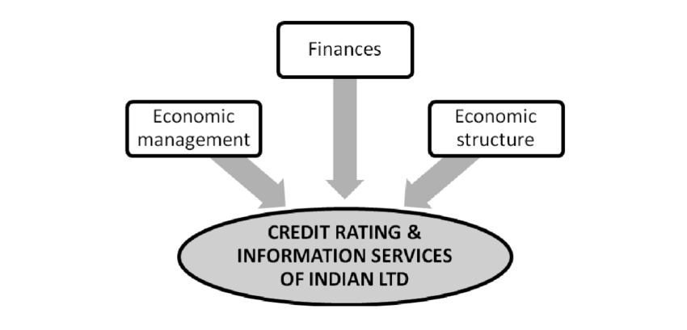

**Training**

The training phase start from 15th January 2020. Training period is of 3 days where various technical topics, which are very important to develop necessary skills required to work in industry, are covered. But before the training start HR also give us pointers about how to conduct ourselves in a corporate environment and help us to settle in. As mention earlier, training period was spanned across 3 days. On the first day of our internship we learn about normal SQL queries and after that we were gradually shifted towards PL/SQL concept.

**About SQL and PL/SQL language :-**

Before talking about what is PL/SQL first we need to learn what SQL language is. SQL is Structured Query Language, which is a computer language for storing, manipulating and retrieving data stored in a relational database. SQL is a language to operate databases; it includes database creation, deletion, fetching rows, modifying rows, etc. SQL is an ANSI (American National Standards Institute) standard language, but there are many different versions of the SQL language.SQL is the standard language for Relational Database System. All the Relational Database Management Systems (RDMS) like MySQL, MS Access, Oracle, Sybase, Informix and SQL Server use SQL as their standard database language.

PL/SQL is a combination of SQL along with the procedural features of programming languages. It was developed by Oracle Corporation in the early 90's to enhance the capabilities of SQL. PL/SQL is one of three key programming languages embedded in the Oracle Database, along with SQL itself and Java. SQL is the standard database language and PL/SQL is strongly integrated with SQL. PL/SQL supports both static and dynamic SQL. Static SQL supports DML operations and transaction control from PL/SQL block. In Dynamic SQL, SQL allows embedding DDL statements in PL/SQL blocks. PL/SQL allows sending an entire block of statements to the database at one time. This reduces network traffic and provides high performance for the applications.

CRISIL as a company is working on various different kinds of projects. Therefore it generate huge amount of data. This data must be stored, queried and retrieve in order to seamless working of day to day business processes. And for that SQL along with PL/SQL is used.

On our second day of training we learn about Java hibernate. Hibernate is a Java framework that simplifies the development of Java application to interact with the database. It is an open source, lightweight, ORM (Object Relational Mapping) tool. Hibernate implements the specifications of JPA (Java Persistence API) for data persistence. Java Persistence API (JPA) is a Java specification that provides certain functionality and standard to ORM tools. The javax.persistence package contains the JPA classes and interfaces. Hibernates primary feature is mapping from Java classes to database tables, and mapping from Java data types to SQL data types. Hibernate also provides data query and retrieval facilities. Hibernate also provides an SQL inspired language called Hibernate Query Language (HQL) for writing SQL-like queries against Hibernate's data objects.

On last day of our training we learn about angular framework. Angular is an application design framework and development platform for creating efficient and sophisticated single-page apps. Using this framework we can easily optimize complex single-page apps for enterprises. This framework was used to overcome obstacles encountered while working with Single Page applications. Also, testing was considered as a key aspect while building the framework. It was ensured that the framework could be easily tested.

Previously angularJS was used for development of single-page application in most of industries. AngularJS uses terms of scope and controller. To scope a variable you can add many variables that will be visible in View as well as in Controller. AngularJS has also a concept of rootScope. Variables in rootScope are available on all throughout application. Angular does not have a concept of scope or controllers. Instead of them it uses a hierarchy of components as its main architectural concept. Also angular is based on TypeScript while AngularJS is based on JavaScript. TypeScript is a superset of ES6 and it’s backward compatible with ES5. Angular has also benefits of ES6 like: lambda operators, iterators or reflection’s mechanism.

We also had sessions over DevOps as well as Containerization using Kubernetes. DevOps is the combination of cultural philosophies, practices, and tools that increases an organization’s ability to deliver applications and services at high velocity: evolving and improving products at a faster pace than organizations using traditional software development and infrastructure management processes. This speed enables organizations to better serve their customers and compete more effectively in the market.

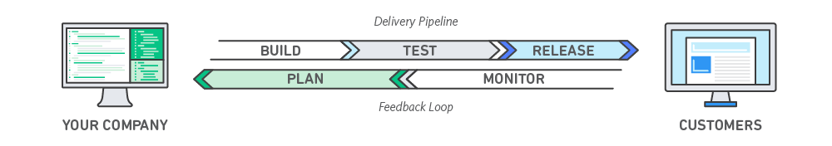

As mention above DevOps is a set of practices that combines software development and IT operations. It aims to shorten the systems development life cycle and provide continuous delivery with high software quality.

**What is Kubernetes ?**

Kubernetes is a portable, extensible, open-source platform for managing containerized workloads and services that facilitates both declarative configuration and automation. It has a large, rapidly growing ecosystem. Kubernetes services, support, and tools are widely available.

Before containerization we used to deploy multiple application using virtualization i.e. to run multiple Virtual Machines (VMs) on a single physical server's CPU. Containers are similar to VMs, but they have relaxed isolation properties to share the Operating System (OS) among the applications. Therefore, containers are considered lightweight. Similar to a VM, a container has its own file system, CPU, memory, process space, and more. As they are decoupled from the underlying infrastructure, they are portable across clouds and OS distributions.

**Amazon Web Service :-**

We also had few online session about how to use AWS effectively. Amazon Web Services (AWS) is a secure cloud services platform, offering compute power, database storage, content delivery and other functionality to help businesses scale and grow. In these sessions we got to learn about various new technologies offered by AWS.

**Amazon EC2 (Elastic Compute Cloud):-**

Amazon Elastic Compute Cloud (Amazon EC2) is a web service that provides resizable computing capacity, servers in Amazon's data centers—that can be used to build and host software systems.

AWS is separated into different services; each can be configured in different ways based on the user's needs. Users should be able to see configuration options and individual server maps for an AWS service. Amazon Web Services portfolio, includes:

• Compute

• Storage databases

• Data management

• Migration

• Hybrid cloud

• Networking

• Development tools

• Big data management

• Analytics

• Artificial intelligence (AI)

Following were the AWS Session taken in the CRISIL:

1. AWS Foundations: Foundation for the AWS is introduction to the cloud services. AWS Cloud and the methods available to interact with various AWS services.

2. AWS Cloud Practitioner Essentials: AWS Cloud Practitioner Essentials is intended for individuals who seek an overall understanding of the AWS Cloud, independent of specific technical roles. It provides a detailed overview of cloud concepts, AWS services, security, architecture, pricing, and support.

**WinSCP:**

WinSCP (Window Secure CoPy) is a free and open-source SFTP, SCP and FTP client for Microsoft Windows. Its main function is secure file transfer between local and remote computers. Beyond this, WinSCP offers basic file manager and file synchronization functionality. For secure transfers, it uses Secure Shell (SSH) and supports the SCP protocol in addition to SFTP protocol. It received 5 out of 5 stars for CNETeditors’ rating and is ranked #2 in popularity for FTP software.

The development of WinSCP started around March 2000 and continues. Originally it was hosted by the University of Economics in Prague, where its author worked at the time. Since July 16, 2003, it is licensed under the GNU GPL and hosted on SourceForge.net.

WinSCP is based on the implementation of SSh protocol from PuTTY and FTP protocol from FileZilla. It is also available as a plugin for two file managers, FAR and Altap Salamander.

**Oracle SQL Developer:**

Oracle SQL Developer (internally often: "sqldeveloper") is an Integrated Development Environment (IDE) for working with SQL in Oracle databases. Oracle Corporation provides this product free; it uses the Java Development Kit. It is a free graphical user interface; Oracle SQL Developer allows database users and administrators to do their database tasks in fewer clicks and keystrokes. A productivity tool, SQL Developer's main objective is to help the end-user save time and maximize the return on investment in the Oracle Database technology stack. SQL Developer supports Oracle Database 10g, 11g, and 12c and will run on any operating system that supports Java.

Oracle SQL Developer is a free integrated development environment that simplifies the development and management of Oracle Database in both traditional and Cloud deployments. SQL Developer offers complete end-to-end development of your PL/SQL applications, a worksheet for running queries and scripts, a DBA console for managing the database, a reports interface, a complete data modeling solution, and a migration platform for moving your 3rd party databases to Oracle.

**Hardware and Software Requirements**

**Hardware Requirement:**

• 4 GB RAM

• 500 MB Hard Disk

• Core i5 6th gen processor

**Software Requirement:**

• Heidi SQL

• Visual Studio Code

• Spring Tool Suite

• WinSCP.

• Git

**Feasibility Study**

A detailed investigation and analysis of a proposed development project to determine whether it is reasonable based on all aspects of the organization is called the Feasibility study. A feasibility study is carried out to select the best system that meets performance requirements. All projects are feasible given unlimited resources and infinite time. Unfortunately, the development of a computer-based system is more likely to be plagued by a scarcity of resources and difficult delivery dates. So, the feasibility study is necessary for every computer-based system. No different is the case of this project.

**Economic Feasibility:**

It is used to evaluate the economic effectiveness of the system. The actual cost of the system is calculated in the economic study. We access the Application through smartphones and tablets and computers which involves no additional software to be installed on the user’s side.

**Technical Feasibility:**

The technical feasibility assessment is focused on gaining an understanding of the present technical resources of the organization and its applicability. The software and hardware requirements to develop and deploy the application are provided by the organization. So, it is technically feasible.

**Operational Feasibility:**

Operational feasibility is a measure of how well a proposed system solves the problems and takes advantage of the opportunities identified during scope definition and how it satisfies the requirements identified in the requirements analysis phase of system development.

**Implementation**

**Software Life Cycle:**

The system life cycle is an organizational process of developing and maintaining systems. It helps in establishing a system project plan because it gives the overall list of processes and sub-processes required for developing a system. The system development life cycle means a combination of various activities. In other words, we can say that various activities put together are referred to as system development life cycle Following are the different phases of the system development life cycle.

• Preliminary study

• Feasibility study

• Detailed system study

• System analysis

• System design

• Coding

• Testing

• Implementation

• Maintenance

**Agile Methodology:**

Agile management or agile project management is an iterative and incremental method of managing the design and build activities for engineering, information technology, and new product or service development projects in a highly flexible and interactive manner, for example, agile software development. It requires capable individuals from the relevant business, with supplier and customer input. There are also links to learn techniques, Kanban and Six Sigma.

Agile techniques are best used in small-scale projects or on elements of a wider program of work, or on projects that are too complex for the customer to understand and specify before testing prototypes. Agile techniques may also be called extreme project management. It is a variant of the iterative life cycle where deliverables are submitted in stages.

The main difference between agile and iterative development is that agile methods complete small portions of the deliverables in each delivery cycle (iteration) while iterative methods evolve the entire set of deliverables over time, completing them near the end of the project. Both iterative and agile methods were developed as a reaction to various obstacles that developed in more sequential forms of project organization.

The result is the product or project that best meets current customer needs and is delivered with minimal costs, waste, and time, enabling companies to achieve bottom-line gains earlier than via traditional approaches.

Adaptive project life cycle, a project life cycle, also known as change-driven or agile methods, that is intended to facilitate change and require a high degree of ongoing stakeholder involvement. Adaptive life cycles are also iterative and incremental, but differ in that iterations are very rapid (usually 2- 4 weeks in length) and are fixed in time and resources.

**Agile Methodology in our Organization:**

In CRISIL, Agile Methodology is highly suitable as projects are developed in two or more phases which meets the client's highly complex and customized needs and purpose.

For example, as technology projects grow in complexity, end-users tend to have difficulty defining the long term requirements without being able to view progressive prototypes. Projects that develop in iterations can constantly gather feedback to help refine those requirements.

In CRISIL, first requirement gathering is done by managers and also checks for feasibility, and also higher-level planning is done at this stage. Then the development team develops the software as per the business requirement document. Here all the ETLs are developed, also the reports and other requirement things are developed in this part.

The next step is testing. The testing is done at the development level and if any bugs found then it is repaired at this level. After the testing, the product is deployed and implement to the client site. At the client site, UAT testing is done before the product is deployed to production. If there is any change required then the product is again sent to the development team for change and again all process is done till the client’s satisfaction.

The last step is system testing. The whole system is tested at the client site. And the final deployment of the product is done at this stage. Agile methodology is perfectly used in CRISIL for developing software.

**My Role as Software Developer:**

* Creating and designing the frontend required to present to the user using Angular 8 or Angular JS.
* Writing an API in backend to implement business logic using Java Spring or Java Spring Boot. In Java Spring Boot, using Beans and JPA to handle the data operation
* Creating and designing the database structure (tables/columns/views) required to store the data which will be used for the analysis.
* Writing queries, procedures, functions, and triggers in MySql.
* Using SQL developer to work on Data migration and performing ETL and migrating data to another system.
* Using Git to save and move the code from branch to branch, merge code with one branch by comparing branches one with another branch and controlling versioning. Git is used for moving code from Dev to Uat and then Production.
* For the containerization, we have used Docker and kubernetes to deal with the deployment of project into separate environment and onto the cloud.
* We also perform unit testing and regression testing by creating and designing various test cases.

**Development Tools**

**Visual Studio Code: -**

Visual Studio Code is a free source-code editor made by Microsoft for Windows, Linux and macOS. It is a source-code editor that can be used with a variety of programming languages, including Java, JavaScript, Go, Node.js and C++. Out-of-the-box, Visual Studio Code includes basic support for most common programming languages. This basic support includes syntax highlighting, bracket matching, code folding, and configurable snippets. Visual Studio Code also ships with IntelliSense for JavaScript, TypeScript, JSON, CSS, and HTML, as well as debugging support for Node.js. Support for additional languages can be provided by freely available extensions on the VS Code Marketplace. We normally use Visual Studio code for writing angularJS or angular 8 code to develop front-end of the application.

**Spring Tool Suite (STS) IDE: -**

Spring Tool Suite is an IDE to develop Spring applications. It is an Eclipse-based development environment. It provides a ready-to-use environment to implement, run, deploy, and debug the application. It validates our application and provides quick fixes for the applications. Spring Tool Suite can be used in various coding environments, ranging from Eclipse as a full-featured integrated development environment to Visual Studio Code and Theia as lightweight code editors. Since this IDE built on architecture of eclipse IDE , we can rum maven, hibernate, spring boot and various other java based project. We normally use STS IDE to design back-end logical layer of our application i.e. we use it to build api which helps us to perform various tasks.

**Heidi SQL:-**

We also use Heidi SQL to create, update or view our databases. Heidi SQL is a free and open-source administration tool for MySQL and its forks, as well as Microsoft SQL Server, PostgreSQL and SQLite.

HeidiSQL has the following GUI features and capabilities.

* Multiple saved sessions with connection and credentials stored within
* Compressed client/server protocol for compatible servers
* Interface with servers via TCP/IP, named pipes (sockets) or a tunneling protocol (SSH)
* Multiple parallelly running sessions in one window
* Manage users on the server: add, remove and edit users, and their credentials
* Manage user privileges globally and per database
* Export databases to SQL files or to other servers
* Multiple query tabs, with each one having multiple subtabs for batch results.
* Create new, alter existing databases' name, character set and collation, drop (delete) databases.

**Git:-**

Git is a distributed version-control system for tracking changes in source code during software development. It is designed for coordinating work among programmers, but it can be used to track changes in any set of files. Its goals include speed, data integrity, and support for distributed, non-linear workflows. Git is designed to handle everything from small to very large projects with speed and efficiency. Git is easy to learn and has a tiny footprint with lightning fast performance. It is designed for coordinating work among programmers, but it can be used to track changes in any set of files. Its goals include speed, data integrity and support for distributed, non-linear workflows.

**Bonitasoft:-**

Bonita is an open source Digital Process Automation platform. To Deliver automation projects rapidly and continuously and increase visibility for insights to improve our processes. As a Developer, Developer focuses on developing the system and we need easy process deployment. Bonita provides a Digital process automation for a competitive edge to Re-invent our business processes: streamline, automate, deliver innovation continuously – and create new business opportunities.

Bonita Continuous Delivery (BCD) fully supports critical collaboration capability between Development and Operations teams. Bonita Continuous Delivery is recognized as a best platform as a service (PaaS) that increases the speed of development of applications, reduces cost of development, automates deployment, and provides flexibility and scalability.

DevOps teams use Bonita to automate the application release process, improve developer productivity, find and address bugs quickly, and deliver updates faster. Bonita is used for Application and process design. Bonita is used like UML diagram to define entity and process flow. A diagram is the representation in the Bonita studio of a group of processes (BPMN pools). A diagram saved, deployed all pools in one action. A diagram has a name and a version number. You can change the diagram name and you can update the version number whenever you want to indicate a major change in the diagram. A pool also has a version number that can be updated manually. There is no link between the diagram version and the pool version.

Bonita provides easy deployment of an project. We just need to create build of an project and upload it to the system. Easy and quick deployment, access via over the internet makes it more easy for developer to work on it.

In our system, we have used front end as Angular 8, API is written in Java Spring Boot and Groovy. It can Support multiple API.

**Testing**

Software testing is an investigation conducted to provide stakeholders with information about the quality of the product or service under test. Software testing can also provide an objective, independent view of the software to allow the business to appreciate and understand the risks of software implementation. Test techniques include, but are not limited to the process of executing a program or application with the intent of finding software bugs (errors or other defects).

Software testing can be stated as the process of validating and verifying that a computer program/application/product:

* + - meets the requirements that guided its design and development
    - works as expected
    - can be implemented with the same characteristics
    - satisfies the needs of stakeholders

Software testing, depending on the testing method employed, can be implemented at any time in the software development process. Traditionally most of the test effort occurs after the requirements have been defined and the coding process has been completed, but in the agile approaches, most of the test effort is on-going. As such, the methodology of the test is governed by the chosen software development methodology.

The following activities are performed by ***CRISIL*** during this phase:-

* + - * Regression Test
      * Internal Testing
      * Unit Testing
      * Application Testing
      * Risk Analysis
      * White Box Testing
      * Black Box Testing
      * User Acceptance Testing

**Regression Testing:**

Quality is usually appraised by a collection of regression tests forming a suite of programs that test one or more features of the system.

A regression test is written and the results are generated. If the results are in error, then the offending bug is corrected. A valid regression test generates verified results.

**Internal Testing:**

Internal testing deals with low-level implementation. Here each function or component is tested. This testing is accomplished by the implementation teams. This focus is also called clear-box testing, or sometimes white-box testing because all details are visible to the test. Internal limits are tested here.

**Unit Testing:**

Unit testing deals with testing a unit as a whole. This would test the interaction of many functions but confine the test within one unit. The exact scope of a unit is left to interpretation. Supporting test code, sometimes called scaffolding, may be necessary to support an individual test. This type of testing is driven by the architecture and implementation teams. This focus is also called black-box testing because only the details of the interface are visible to the test. Limits that are global to a unit are tested here.

**Application Testing:**

Application testing deals with tests for the entire application. This is driven by the scenarios from the analysis team. Application limits and features are tested here.

The application must successfully execute all scenarios before it is ready for general customer availability. After all, the scenarios are a part of the requirement document and measure success. Application testing represents the bulk of the testing done by industry.

Unlike the internal and unit testing, which are programmed, these tests are usually driven by scripts that run the system with a collection of parameters and collect results. In the past, these scripts may have been written by hand but in many modern systems, this process can be automated.

The entire testing here is carried out on the GUI interface of the application. A separate application testing team is n place which ensures that all the critical elements of the application are thoroughly tested when a new version/ new module/ An existing bug is corrected.

**Risk Analysis:**

Risk Analysis is a technique used to identify and assess factors that may jeopardize the success of a project or achieving a goal.

The Rating System is a method to perform risk analysis. This technique also helps to define a preventive measure to reduce the probability of these factors from occurring. The Rating System uses a rating technique to identify the risk in the project. Ratings through 1 to 5, 1 being best. This technique is used by QC Team. QC Team will give a rating to the project.

**White Box Testing:**

White-box testing (also known as clear box testing, glass box testing, transparent box testing, and structural testing) is a method of testing [software](http://en.wikipedia.org/wiki/Software) that tests internal structures or workings of an application, as opposed to its functionality (i.e. [black-box testing](http://en.wikipedia.org/wiki/Black-box_testing)). In white-box testing, an internal perspective of the system, as well as programming skills, are used to design test cases. The tester chooses inputs to exercise paths through the code and determine the appropriate outputs. This is analogous to testing nodes in a circuit, e.g. [in-circuit testing](http://en.wikipedia.org/wiki/In-circuit_test) (ICT).

White-box testing can be applied at the [unit](http://en.wikipedia.org/wiki/Unit_testing), [integration,](http://en.wikipedia.org/wiki/Integration_testing) and [system](http://en.wikipedia.org/wiki/System_testing) levels of the [software testing](http://en.wikipedia.org/wiki/Software_testing) process. Although traditional testers tended to think of white-box testing as being done at the unit level, it is used for integration and system testing more frequently today. It can test paths within a unit, paths between units during integration, and between subsystems during a system-level test. Though this method of test design can uncover many errors or problems, it has the potential to miss unimplemented parts of the specification or missing requirements.

White-box test design techniques include the following [code](http://en.wikipedia.org/wiki/Code_coverage) [coverage](http://en.wikipedia.org/wiki/Code_coverage) criteria:

* + - [Control flow](http://en.wikipedia.org/wiki/Control_flow) testing
    - Data flow testing
    - Branch testing
    - Statement coverage
    - Decision coverage
    - [Modified condition/decision coverage](http://en.wikipedia.org/wiki/Modified_condition/decision_coverage)
    - Prime path testing
    - Path testing

**Black Box Testing:**

Black-box testing is a method of [software testing](http://en.wikipedia.org/wiki/Software_testing) that examines the functionality of an application (e.g. what the software does) without peering into its internal structures or workings. This method of test can be applied to virtually every level of software testing: unit, integration, system, acceptance It typically comprises most if not all higher-level testing, but can also dominate [unit testing](http://en.wikipedia.org/wiki/Unit_testing) as well. Specific knowledge of the application's code/internal structure and programming knowledge, in general, is not required. The tester is aware of *what* the software is supposed to do but is not aware of *how* it does it. For instance, the tester is aware that a particular input returns a certain, invariable output but is not aware of *how* the software produces the output in the first place.

**User Acceptance Testing:**

User Acceptance testing is the software testing process where system tested for acceptability & validates the end to end business flow. Such type of testing executed by the client in a separate environment (similar to the production environment) & confirms whether the system meets the requirements as per requirement specification or not.

UAT is performed after System Testing is done and all or most of the major defects have been fixed. This testing is to be conducted in the final stage of the Software Development Life Cycle (SDLC) before the system being delivered to a live environment. UAT users or end users are concentrating on end to end scenarios & typically involves running a suite of tests on the completed system.

The Acceptance testing is “black box” tests, which means UAT users doesn’t aware of the internal structure of the code, they just specify the input to the system & check whether systems respond with the correct result.

**User Acceptance testing** also is known as Customer Acceptance testing (CAT), if the system is being built or developed by an external supplier. The CAT or UAT is the final confirmation from the client before the system is ready for production.

The business customers are the primary owners of these UAT tests. These tests are created by business customers and articulated in business domain languages. So ideally it is a collaboration between business customers, business analysts, testers, and developers.

It consists of test suites that involve multiple test cases & each test case contains input data (if required) as well as the expected output. The result of the test case is either a success or not success.

**Conclusion**

In today’s world, Application development is on rapid growth. It requires sophisticated design, robust code design, security features and continuously integration and continuous delivery.

Complex applications are accessible to intended users through any web enabled device. It is a simple and interactive user interface that makes it responsive and more optimal in processing. Data is key to decision making and it is required to store in an efficient manner using different formats.

analyses, insights and solution provided help lenders, borrowers, issuers, investors, regulators and intermediaries make sound decisions and it also help clients manage and mitigate risks, take pricing and valuation decisions, reduce time to market, generate more revenue and enhance returns.

By helping shape public policy on infrastructure in emerging markets, CRISIL helps catalyse economic growth and development in these geographies.

**References:**

* <https://www.crisil.com/>
* <https://aws.amazon.com/>
* <https://www.heidisql.com/>
* <https://www.docker.com/resources/>
* <https://winscp.net/eng/index.php>
* <https://devops.com/>
* <https://en.wikipedia.org/wiki/Visual_Studio_Code>
* <https://en.wikipedia.org/wiki/HeidiSQL>